Mobile identity-verification plugin

What this component is, and what it is not

A Cordova plugin embedded in the bank's mobile application. It reads ICAO 9303 electronic identity documents(passports and national ID cards) over NFC, scans the printed machine-readable zone with the camera,photographs the document, runs a challenge–response liveness check, and compares the holder's face against theportrait stored on the document's chip.
It is a data-collection and evidence-gathering component. It is not a decision engine.
It returns measurements — a chip payload, a similarity score, a set of checks that passed or failed — to the host application, which forwards them to the bank's backend. The accept/reject decision, and every threshold behind it, lives in thebackend and is deliberately not shipped in the app.
Property | Value
Execution context | In-process native code inside the bank's own mobile application
Processing location | Entirely on the customer's handset
Server-side components | None. The plugin has no backend of its own.
Outbound network connections madeby the plugin | None
Data persisted by the plugin | None beyond transient temporary fi les, deleted within the same call
Platforms | Android (Java), iOS 15.5+ (Swift 5)

Component architecture
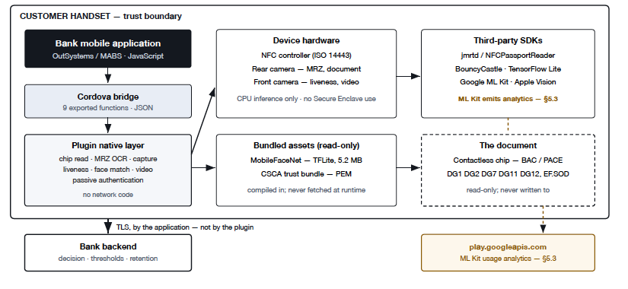

Third-party framework inventory

- Android
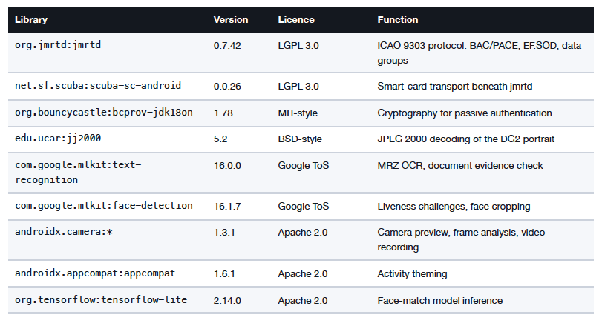
- iOS
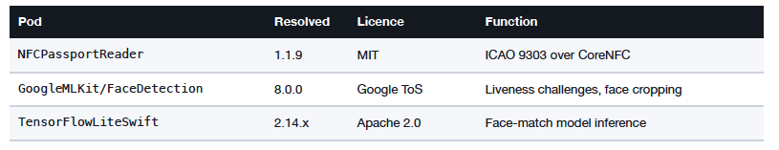
Apple frameworks used directly, with no third party involved:
CoreNFC, Vision (all OCR on iOS), AVFoundation,UIKit, CoreGraphics, ImageIO. OCR on iOS is Apple Vision, not ML Kit — and Vision recognises Arabic, which MLKit has no model for.

- Bundled model
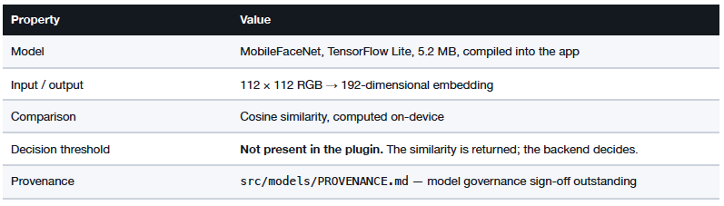

Processing flow

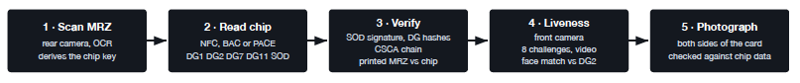
Why this order
The MRZ must be read first because it derives the chip access key. The chip must be read before the photographs, so the print-versus-chip comparison happens while the customer still holds the document.
Single JSON result → host application → bank backend over the application's own TLS channel
document fields · DG2 portrait · passive-authentication verdict · MRZ/chip comparison · liveness result
challenge frames · session video · face-match similarity (a number, not a decision) · document photograph
Nothing is written to durable storage by the plugin. Temporary video fi les are deleted within the same call.

